IKS ASSIGNMENT

NAME: PUNEET UPADHAYAY
ROLL NO. 02215603123
SUBJECT: INDIAN KNOWLEDGE SYSTEM
SUBJECT CODE: ECC-253

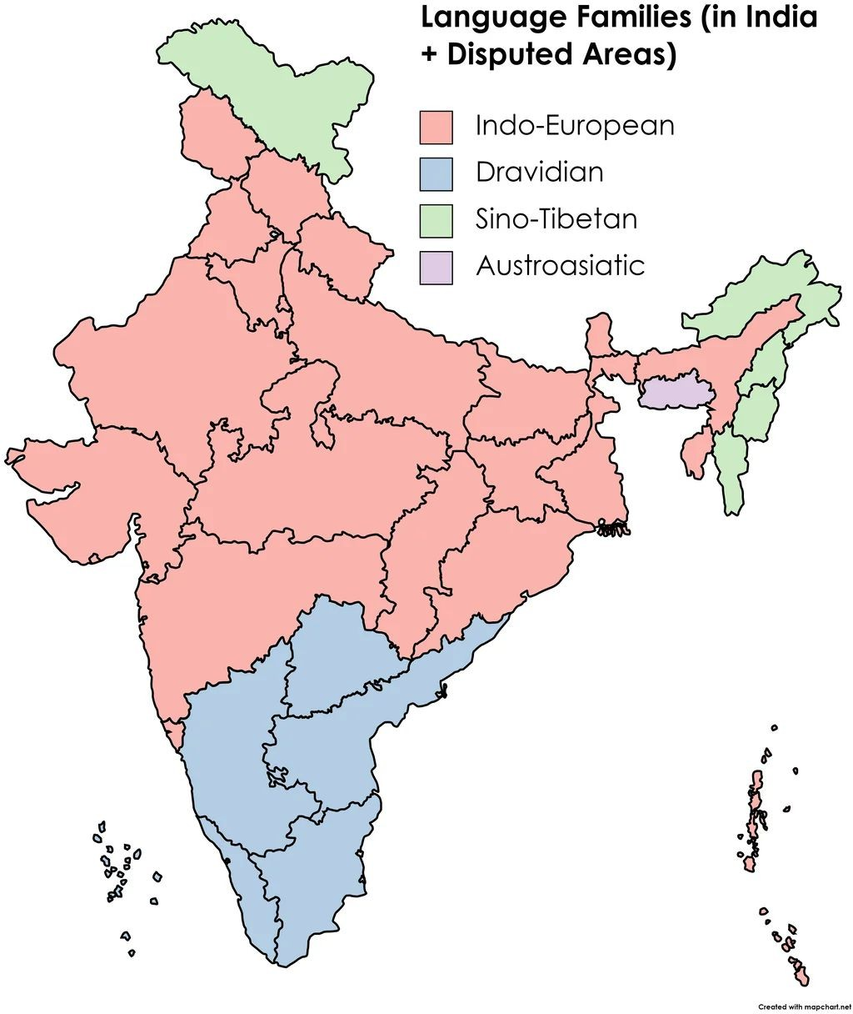
INDIAN LINGUISTICS

Indo-European Dravidian Sino-Tibetan Austro-Asiatic

- Hindi
- Bengali
- Marathi
- Gujarati
- Telugu
- Tamil
- Kannada
- Tibetan ● Santhali
- Meitei

  - Hindi

INDO-EUROPEAN

Geographical Location: Primarily spoken in Northern India (Uttar Pradesh, Bihar, Madhya Pradesh, Rajasthan, Delhi, Haryana, Punjab, etc.) Description- Hindi is the most widely spoken language in India and the ofﬁcial language of the government. It is written in the Devanagari script and has evolved from Sanskrit. It is rich in literature, arts, and cinema, with a signiﬁcant impact on Indian culture.

Bengali
Geographical Location: Mainly spoken in West Bengal and
Tripura, and in parts of Assam (Barak Valley).
Description: Bengali is the second-most spoken language in India and has a long history in literature, arts, and science. It uses the Bengali script and is the primary language of Bangladesh as well, where it is known as Bangla. It has a thriving literary tradition, with famous poets like Rabindranath Tagore.

Marathi
Geographical Location: Mainly spoken in West Bengal and Tripura, and in parts of Assam (Barak Valley).
Description: Marathi is one of the oldest languages in India with a rich
literary tradition. It uses the Devanagari script and has been a medium for various famous literary works and theater. Marathi is the ofﬁcial language of Maharashtra, with diverse dialects spoken across the state.

Gujarati
Geographical Location: Predominantly spoken in Gujarat. Description: Gujarati is the native language of the state of Gujarat and is known for its distinct script. It has a vibrant literary and cultural tradition, and is the language of famous ﬁgures like
Mahatma Gandhi. It is also spoken by signiﬁcant diaspora
communities.

- Telugu
DRAVIDIAN

Geographical Location: Primarily spoken in Andhra Pradesh
and Telangana.
Description: Telugu is known for its melodic quality and is one of the classical languages of India. It uses the Telugu script and is one of the most spoken languages in India. Telugu has a rich literary and ﬁlm heritage, with Tollywood being the second-largest ﬁlm industry in India.

Tamil
Geographic Location: Spoken in Tamil Nadu, Puducherry, and parts of Sri Lanka and Singapore.
Description: Tamil is one of the oldest classical languages in the world, with a rich literary tradition going back over 2,000 years. It uses the Tamil script and has a signiﬁcant inﬂuence on the culture and traditions of Tamil Nadu. Tamil is also an ofﬁcial language in Sri Lanka and Singapore.

Kannada
Geographical Location: Primarily spoken in Karnataka. Description: Kannada is one of the oldest languages of the Dravidian family, with a well-established literary tradition. It uses the Kannada script and is known for its poetry, classical music, and dance forms.
Kannada is also an ofﬁcial language of Karnataka.

SINO-TIBETAN
  - Tibetan
Geographical Location: Primarily spoken in Tibet (China), as well as parts of Ladakh and Himachal Pradesh in India, and Nepal and Bhutan
Description: Tibetan is an Indo-Aryan language with its own script, called the Tibetan script. It is used mainly by the Tibetan and Buddhist communities. Tibetan has a rich spiritual and literary
heritage, with signiﬁcant works in philosophy, religion, and poetry. It is one of the primary languages of the Tibetan Buddhist tradition.

  - Meitei (Manipuri)

Geographical Location: Spoken in the state of Manipur in

Northeast India.
Description: Meitei, also known as Manipuri, is the predominant language of the state of Manipur and is part of the Tibeto-Burman language family. It is written in the Meitei Mayek script (though the Bengali script is also used). Meitei is a classical language of India and plays a crucial role in the cultural and artistic traditions of the Manipuri people, including dance, music, and literature.

AUSTRO ASIATIC

1)Santali

Geographical Location: Spoken predominantly in the states of Jharkhand, West Bengal, Orissa, Bihar, and Assam, and also in parts of Bangladesh and Nepal.

Description: Santali is a Munda language in the Austroasiatic family. It is spoken by the Santali people, an indigenous community, and has its own script, the Ol Chiki script, which was created in the 1920s. Santali has a rich oral tradition and is important for the cultural identity of the Santal tribe.

PANINI: THE FATHER OF LINGUISTICS

Panini: A Pioneering Figure in Ancient Linguistics
Panini, who lived around the 4th century BCE in what is now Pakistan, is widely recognized for his groundbreaking contributions to the study of Sanskrit grammar. His work has had a lasting impact on linguistics, inﬂuencing language studies both in ancient and modern times.

The Ashtadhyayi: A System of Sanskrit Grammar
Panini’s most famous work, the Ashtadhyayi, is a systematic guide to Sanskrit grammar, composed of nearly 4,000 succinct rules. This text is one of the earliest examples of a structured grammatical system, meticulously detailing the workings of Sanskrit with remarkable precision.
Structure and Methodology
The Ashtadhyayi is organized around sound patterns and word structures, which dictate how words and sentences are formed. Panini's rules are designed for repeated application, enabling the generation of countless sentences. His approach foreshadows the organization seen in modern grammatical frameworks.
Innovative Notation System
One of Panini’s major innovations was his simpliﬁed notation system, similar to mathematical symbols, which he used to keep his grammatical rules clear and concise. This early rule-based model made Sanskrit grammar accessible and became an inﬂuential concept in later language studies.

Legacy and Inﬂuence on Linguistics
Panini’s work went beyond Sanskrit, providing a foundational framework for structural language studies. His methods inﬂuenced scholars in India and, eventually, in the West. Notable ﬁgures like Ferdinand de Saussure and Noam Chomsky drew inspiration from Panini's concepts, particularly in recognizing language as a system governed by patterns.

Connection to Modern Language Theory
Many of Panini’s insights, such as sound and word-building patterns, resonate with current linguistic theories, illustrating his profound understanding of language. His work not only preserved Sanskrit but also established principles that continue to shape the study of linguistics.

